**INTRODUCTION OF SUBJECT**

**1.1 What is Web development ?**

Web programming, also known as web development, is the creation of dynamic web applications. Examples of web applications are social networking sites like Facebook or e-commerce sites like Amazon.

The good news is that learning web development is not that hard!

In fact, many argue it’s the [**best form of coding**](https://www.codeconquest.com/what-is-coding/where-to-start/) for beginners to learn. It’s easy to set up, you get instant results and there’s plenty of online training available.

A lot of people learn web coding because they want to create the next Facebook or find a job in the industry. But it’s also a good choice if you just want a general introduction to coding, since it’s super easy to get started. No matter whether you’re looking for a career or just want to learn coding, learning how to develop for the web is for you. It’s one of the smartest decisions you will ever make!

**1.2 Overview**

Front-end development refers to constructing what a user sees when they load a web application – the content, design and how you interact with it. This is done with three codes – HTML, CSS and JavaScript.

HTML, short for [**Hyper Text Markup Language**](https://www.codeconquest.com/tutorials/html/), is a special code for ‘marking up’ text in order to turn it into a web page. Every web page on the net is written in HTML, and it will form the backbone of any web application. CSS, short for [**Cascading Style Sheets**](https://www.codeconquest.com/tutorials/css/), is a code for setting style rules for the appearance of web pages. CSS handles the cosmetic side of the web. Finally, [**JavaScript**](https://www.codeconquest.com/tutorials/javascript/) is a scripting language that’s widely used to add functionality and interactivity to web pages.

Back-end development controls what goes on behind the scenes of a web application. A back-end often uses a database to generate the front-end.

Back-end scripts are written in many different coding languages and frameworks, such as…

* PHP
* RubyOnRails
* ASP.NET
* Perl
* Java
* Node.js
* Python

**INTRODUCTION OF PROJECT**

**2.1 Front End**

**2.1.1 HTML:**

There are two parts in website one is design and other one is development. For developing good website you should do design of website very well. For design mostly designers use HTML language because it is the primary language and easy to use by designers.

HTML stands for Hyper Text Markup Language. It is simplest language which is created by human beings and it is used for creating static websites to provide information to humans.

**2.1.2 CSS:**

When you create a website for your business, time and money are likely to be major concerns. Luckily, there is a web design method that can help you save time and money while also improving your visitor's experience.

Cascading Style Sheets, more commonly known as CSS, has fast become the preferred web design method for the benefits it offers web designers and website visitors alike.

CSS is a language used to detail the presentation of a web page's markup language (most commonly HTML or XHTML) – such as colors, fonts, and layout. One of its key benefits is the way it allows the separation of document content (written in HTML or a similar markup language) from document presentation (written in CSS).

**2.1.3 JavaScript:**

It is used in millions of web pages to improve the design, validate form, detect browsers, and creates cookies and much more. Java Script is the most popular scripting language on the Internet, and works in all major browsers, such as Internet Explorer, Mozilla Firefox, Netscape, and Opera.

Java Script was design to add interactivity to HTML pages. It is scripting language. It consists of line of executable computer code. It is usually embedded directly into HTML pages. It is an interpreted language. Everyone can use java script without purchasing a license. It is most widely used for validation and dynamic effects.

**2.1.4 Back End**

Firebase for real time database.

**PROJECT DETAILS**

**3.1 Introduction**

Web Developer Bootcamp, the **only course you need to learn web development.**There are a lot of options for online developer training, but this course is without a doubt the most comprehensive and effective on the market.  Here's why:

* This is the only online course taught by a professional bootcamp instructor.
* **94% of my in-person bootcamp students go on to get full-time developer jobs**. Most of them are complete beginners when I start working with them.
* The previous 2 bootcamp programs that I taught cost **$14,000 and $21,000**.  This course is just as comprehensive but with brand new content for a fraction of the price.
* Everything I cover is up-to-date and relevant to today's developer industry.**No PHP or other dated technologies. This course does not cut any corners.**
* This is the only complete beginner full-stack developer course that covers NodeJS.
* We build 13+ projects, including a **gigantic production application**called YelpCamp. No other course walks you through the creation of such a substantial application.
* The course is **constantly updated** with new content, projects, and modules.  Think of it as a subscription to a never-ending supply of developer training.

**3.2 What you’ll learn**

* Make REAL web applications using cutting-edge technologies
* Continue to learn and grow as a developer, long after the course ends
* Create a blog application from scratch using Express, MongoDB, and Semantic UI
* Create a complicated yelp-like application from scratch
* Write your own browser-based game
* Create static HTML and CSS portfolio sites and landing pages
* Think like a developer. Become an expert at Googling code questions!
* Create complex HTML forms with validations
* Write web apps with full authentication
* Use Bootstrap to create good-looking responsive layouts
* Implement responsive navbars on websites
* Use JavaScript variables, conditionals, loops, functions, arrays, and objects
* Write Javascript functions, and understand scope and higher order functions
* Create full-stack web applications from scratch

## 3.3 LINKS

## 3.3.1 CSS Files and Structure.

## <link href="css/linearicons.css" rel="stylesheet">

<**link** href="css/owl.carousel.css" rel="stylesheet">

<**link** href="css/font-awesome.min.css" rel="stylesheet">

<**link** href="css/nice-select.css" rel="stylesheet">

<**link** href="css/magnific-popup.css" rel="stylesheet">

<**link** href="css/bootstrap.css" rel="stylesheet">

<**link** href="css/main.css" rel="stylesheet">

**3.3.2 Google Web Fonts**

<**link** href="<https://fonts.googleapis.com/css?family=Montserrat:300>,500,600" rel="stylesheet">

<**link** href="<https://fonts.googleapis.com/css?family=Roboto:300>,400,500i" rel="stylesheet">

**3.3.3 Javascript Files and Structure**

**<script** src="js/vendor/jquery-2.2.4.min.js"></**script**>

<**script** src="<https://cdnjs.cloudflare.com/ajax/libs/popper.js/1.11.0/umd/popper.min.js>" crossorigin="anonymous" integrity="sha384-b/U6ypiBEHpOf/4+1nzFpr53nxSS+GLCkfwBdFNTxtclqqenISfwAzpKaMNFNmj4"></**script**>

<**script** src="js/vendor/bootstrap.min.js"></**script**>

<**script** src="js/jquery.ajaxchimp.min.js"></**script**>

<**script** src="js/owl.carousel.min.js"></**script**>

<**script** src="js/jquery.nice-select.min.js"></**script**>

<**script** src="js/jquery.magnific-popup.min.js"></**script**>

<**script** src="js/main.js"></**script**>

|  |  |
| --- | --- |
|  |  |

**SNAPSHOTS**

**HOME SCREEN**

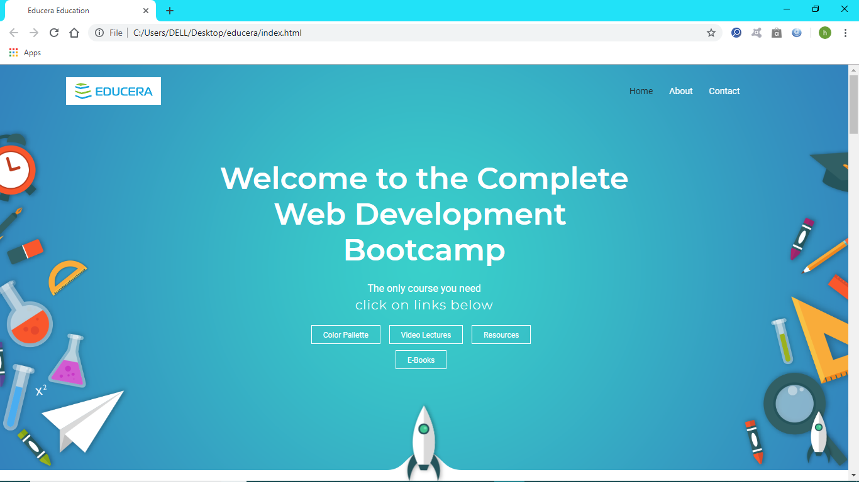

**WHY US!**

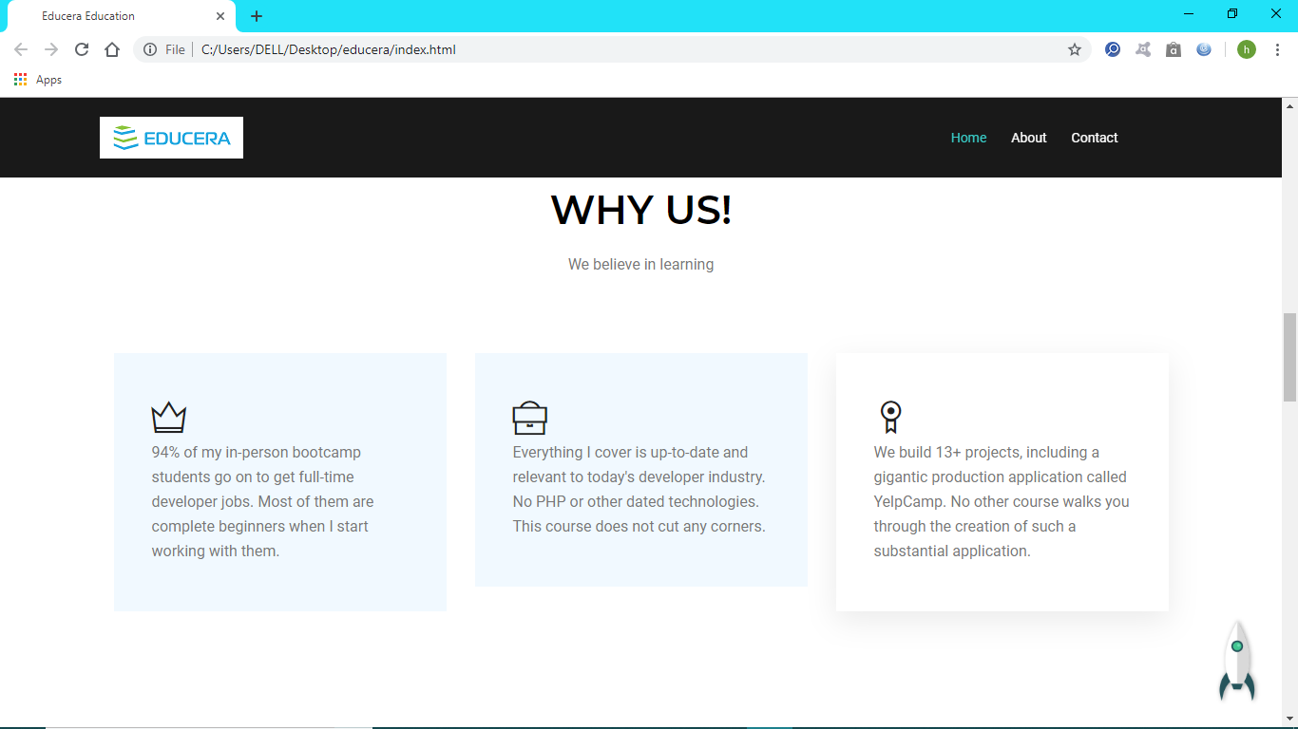

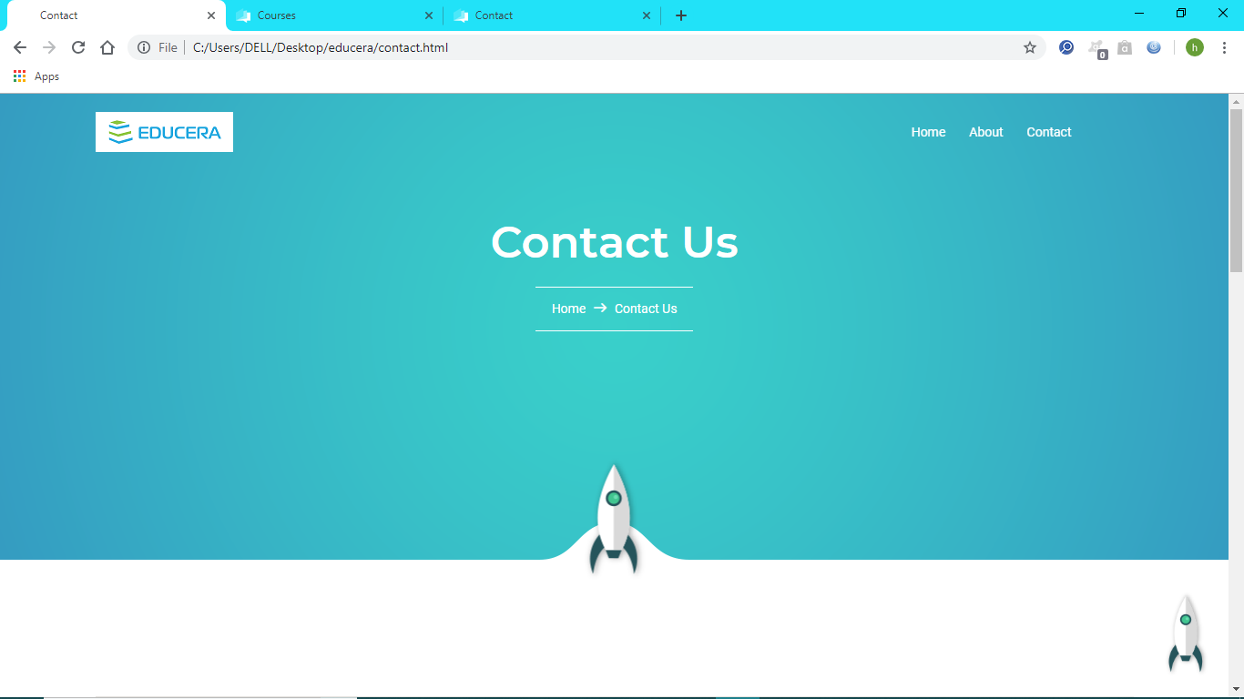**CONTACT US**

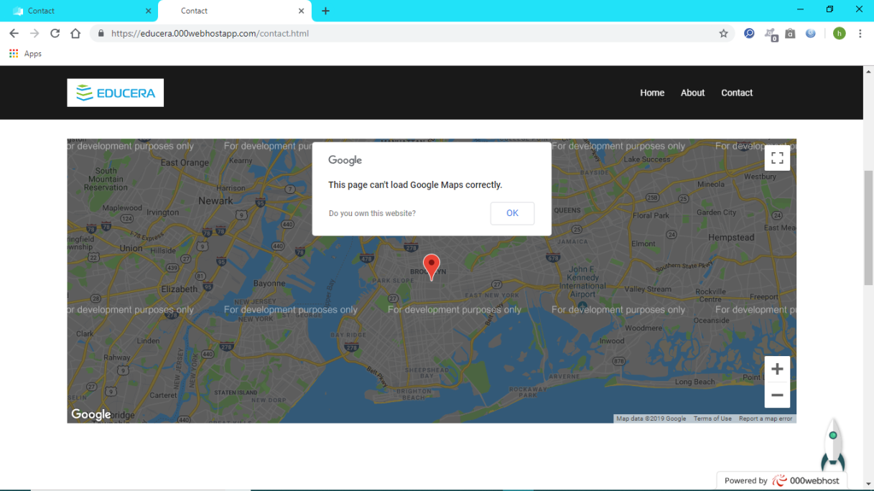**GOOGLE MAPS**

**FEEDBACK FORM**

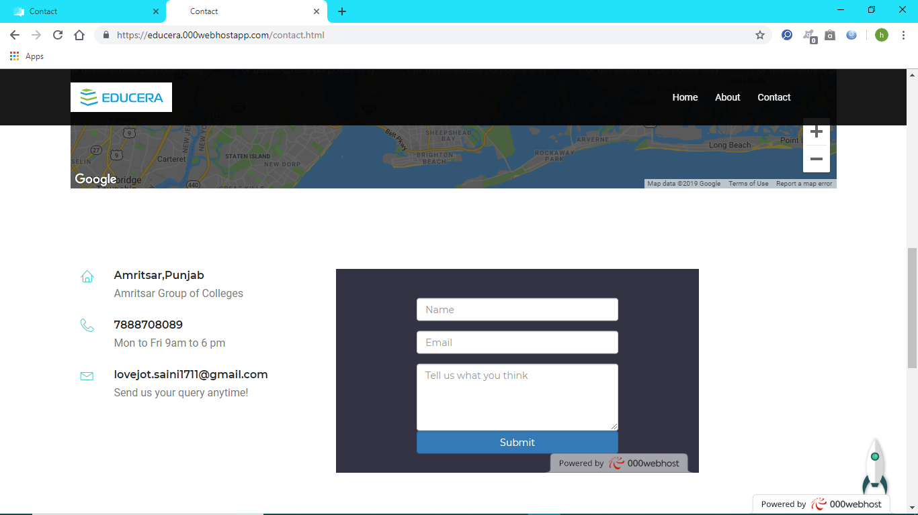

**ABOUT US**

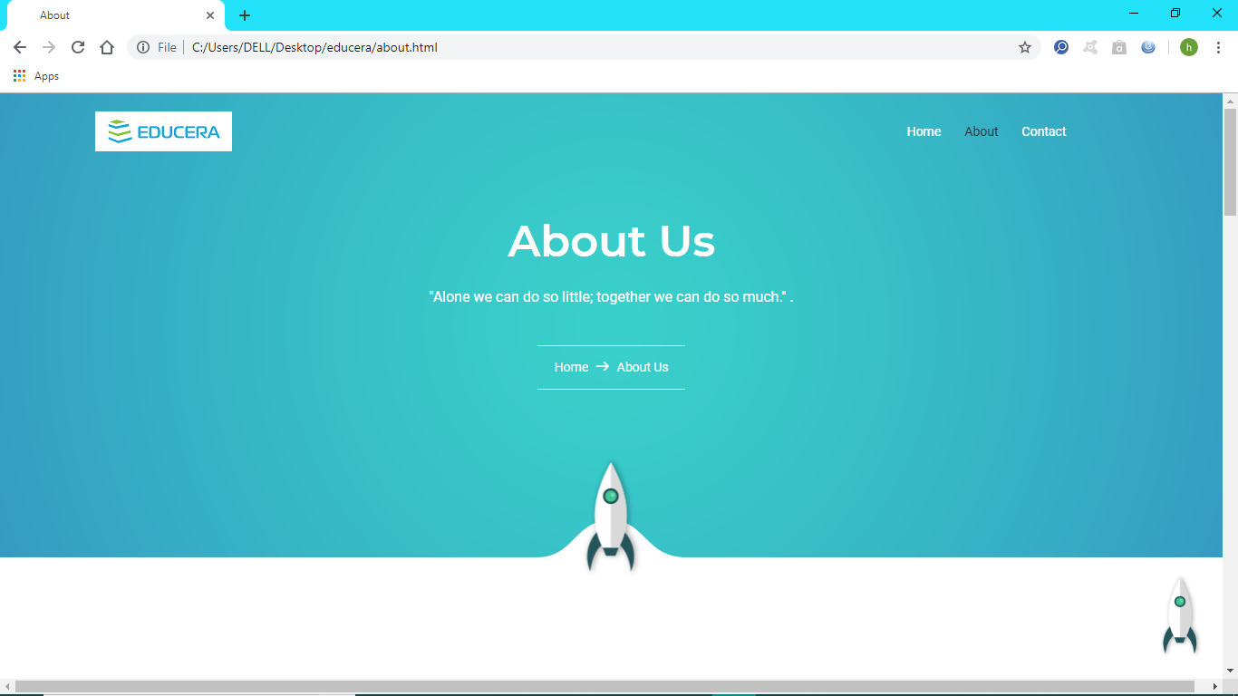

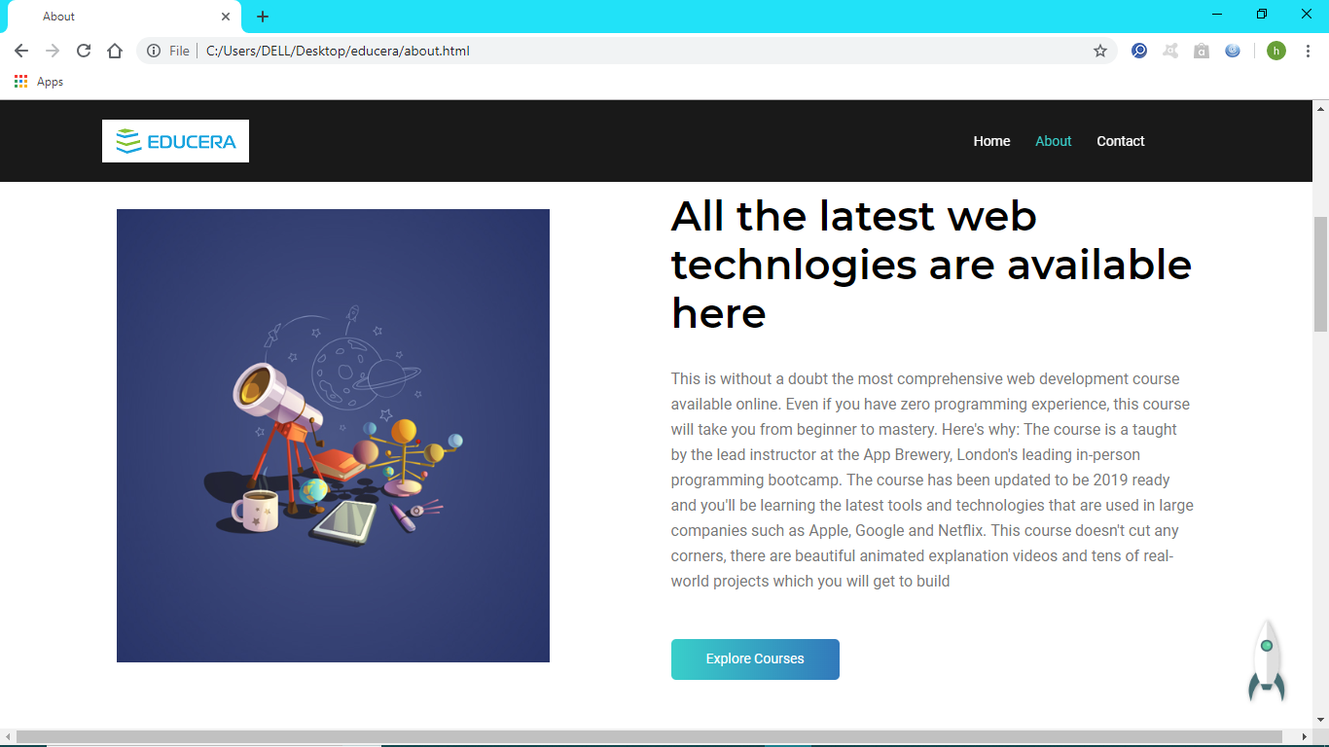

**FACULTY MEMBERS**

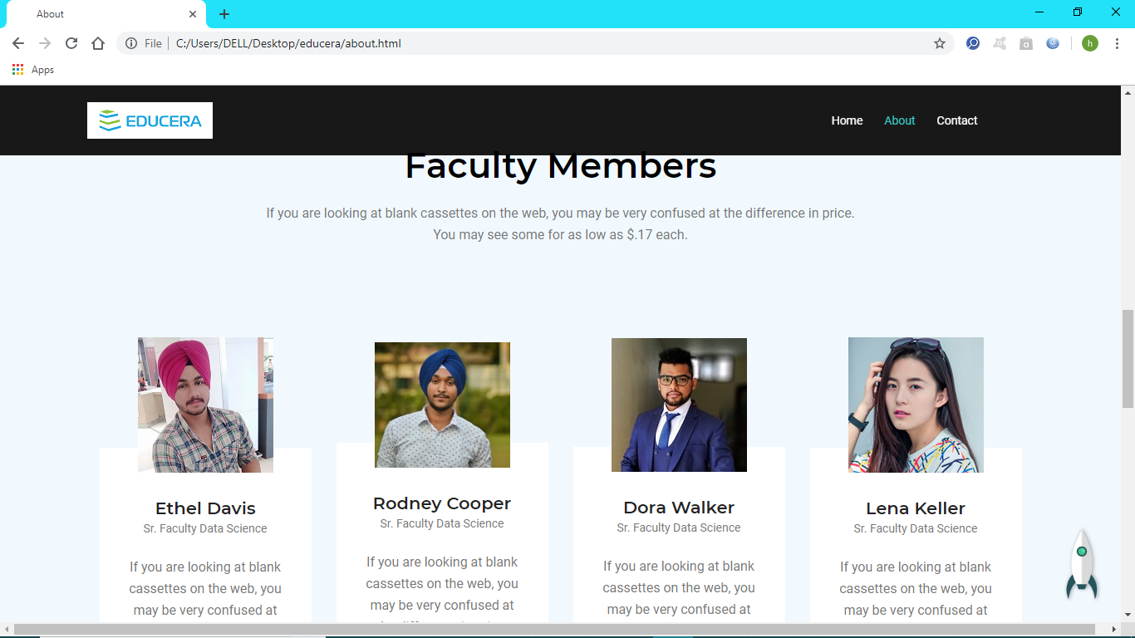

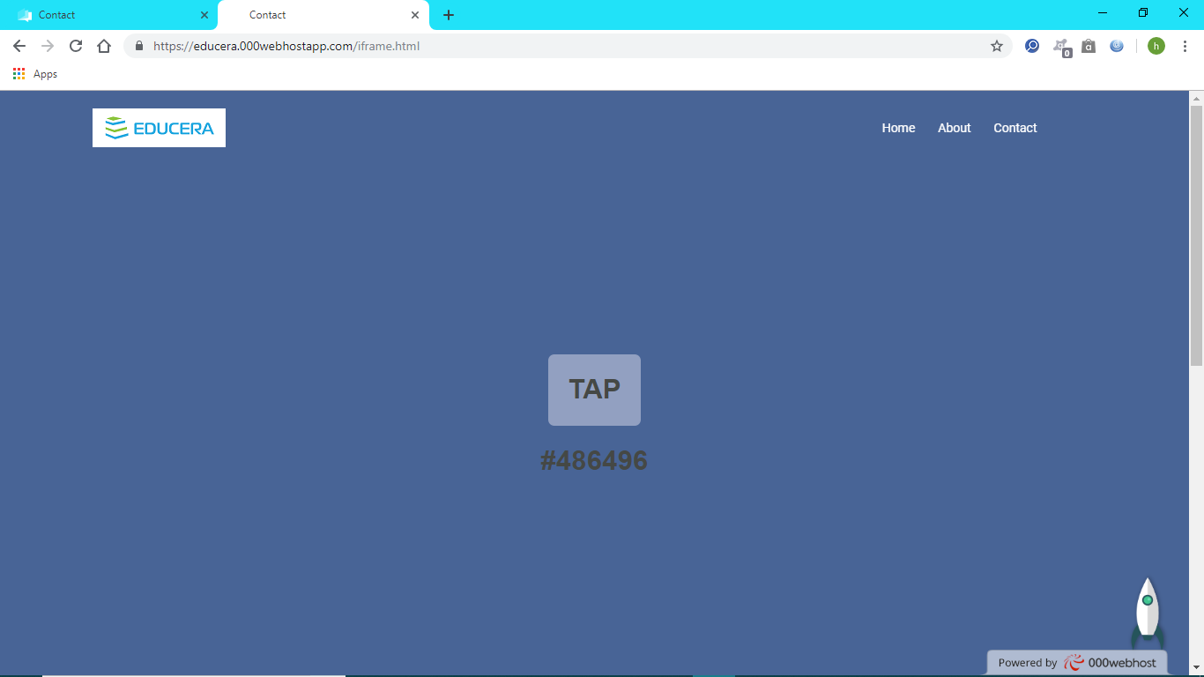**PALLETE GENERATOR**

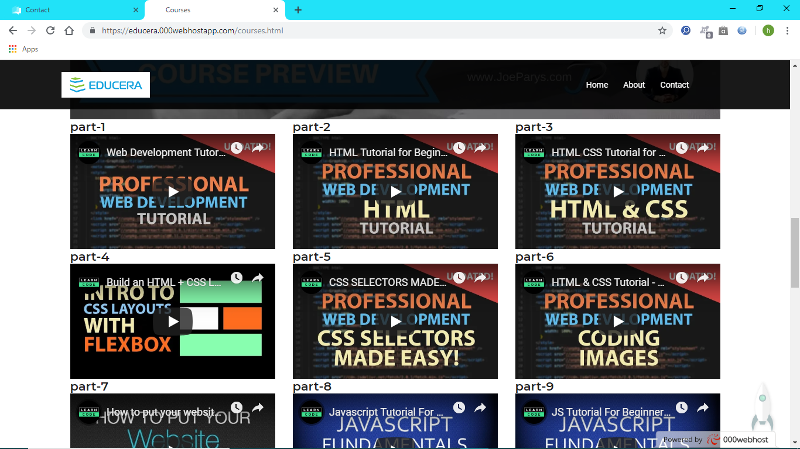**VIDEO LECTURES**

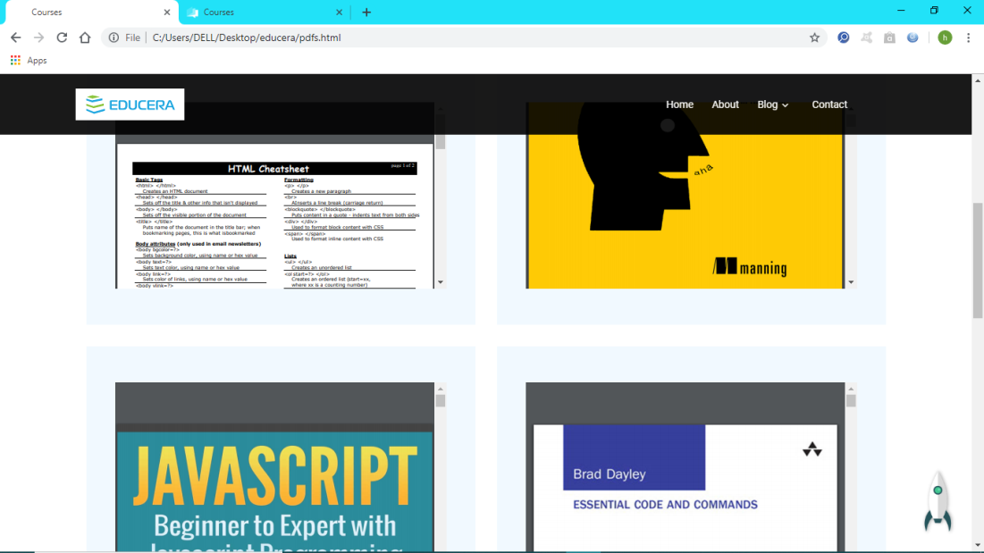**PDF’s**

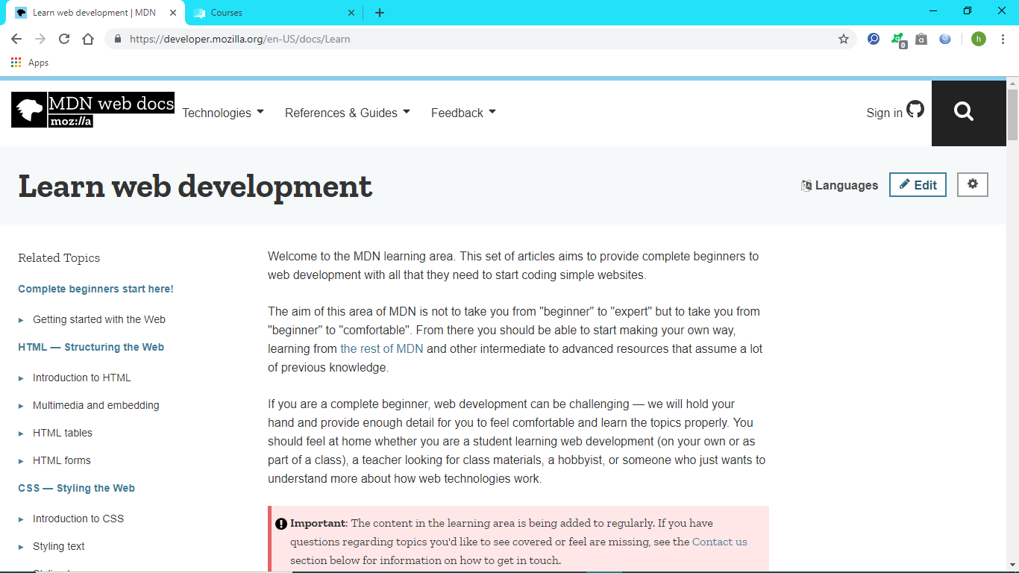**EXTERNAL RESOURCE**

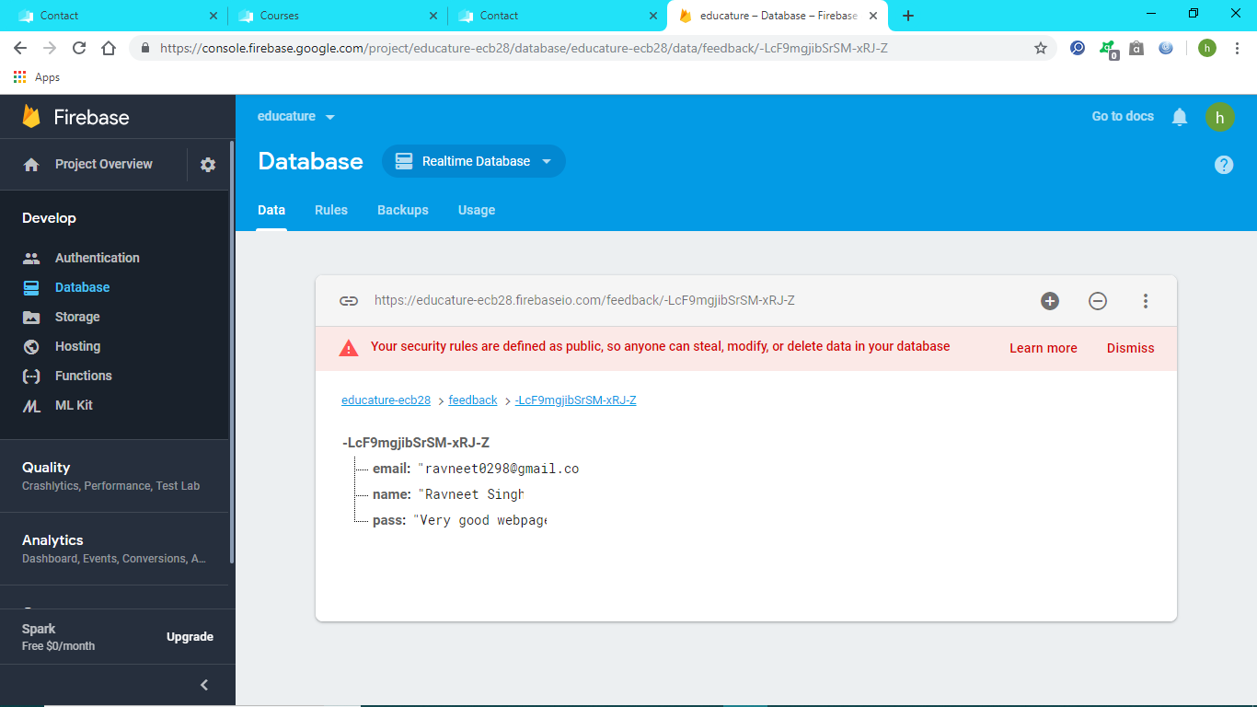**FIREBASE-back end**